 |  |  | (Original for Recipient)
Invoice Date: 05 July, 2025 |  |  | Order Date: {orderDate}
Invoice No: LXS-INV-05072025-00001 |  |  | Order ID: {orderId}
Sold By: |  |  | Contact No: +91 6203293568
LXSLIFESTYLESTORE (OPC) PRIVATE LIMITED |  |  | Email: sachinofficialme24@gmail.com
Billing Address: Sachin Kumar |  |  | Shipping Address: Sachin Kumar
H. No-34/C, Village Choura, Road Chas |  |  | H. No-34/C, Village Choura, Road Chas
Near Hanuman Mandir, P.O-Narayanpur |  |  | Near Hanuman Mandir, P.O-Narayanpur
Pindrajora, Bokaro, Jharkhand, INDIA, 827013 |  |  | Pindrajora, Bokaro, Jharkhand, INDIA, 827013
State / UT Code: 20 |  |  | State / UT Code: 20
Total: 04 Items |  | All amount is in INR ₹ value
Sl. No | Product Details  (Description) |  |  | Qty | Gross  Amount | Discounts | Taxable  Value | IGST (5%) | Total
1 | Men Micro Print Slim Fit Shirt |  |  | 1 | 2299.00 | 874.00 | 1357.14 | 67.86 | 1425.00
2 | Logo Print Loose Fit Hoodie |  |  | 1 | 2499.00 | 1249.00 | 1190.48 | 59.52 | 1250.00
3 | Men Oversized Cargo Joggers |  |  | 1 | 3199.00 | 2207.00 | 944.76 | 47.24 | 992.00
4 | Men Mid-Wash 512 Slim Tapered Fit Jeans |  |  | 1 | 3199.00 | 1727.00 | 1401.90 | 70.10 | 1472.00
Total: |  |  |  | 4 | 11196.00 | 6057.00 | 4894.28 | 244.72 | 5139.00
Grand Total ₹: 5139.00
Amount in Words: Five Thousand One Hundred Thirty-Nine Only
LXSLIFESTYLESTORE (OPC) PRIVATE LIMITED
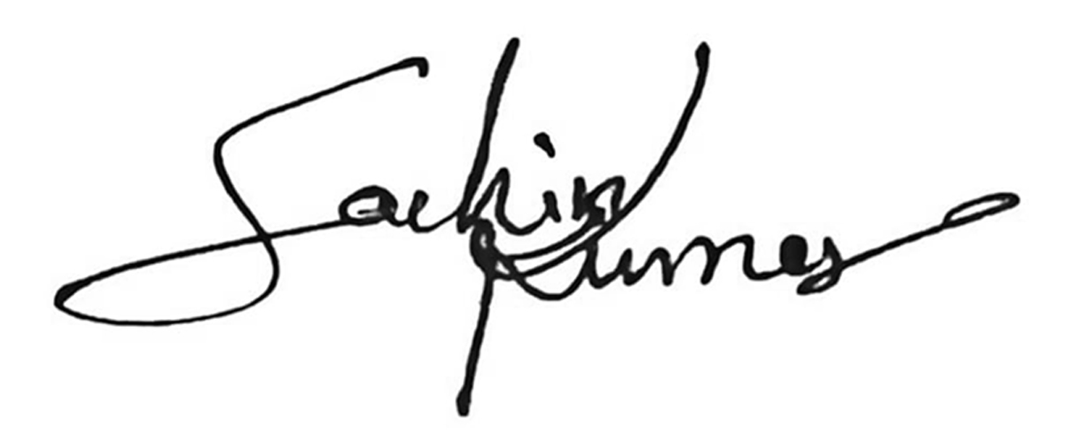
Authorized Signatory
If you have any questions concerning this invoice, reach out at www.lxs-lifestyle-store.com/helpcentre
Contact us at: +91 8987888368, contact@lxs-lifestyle-store.com
Thank You !
for shopping with LXS Store: A Universe of Innovation, Fashion and Creativity!

